**CURRICULUM**

**VITAE**

**OF**

**AL**

**IMRAN**

**EMON**

House

63

,

3

no

Wasa

Road,

West

Shewrapara,

Mirpur,

Dhaka

1216

Cell:

+880

15

6795

4701

E-mail:

alemonimran@gmail.com

Linkedin:

[linkedin.com/in/alimranemo](https://www.linkedin.com/in/alimranemon?lipi=urn%3Ali%3Apage%3Ad_flagship3_profile_view_base_contact_details%3BBoby09WHS5%2B1q6vhZ%2FneKA%3D%3D)

[n](https://www.linkedin.com/in/alimranemon?lipi=urn%3Ali%3Apage%3Ad_flagship3_profile_view_base_contact_details%3BBoby09WHS5%2B1q6vhZ%2FneKA%3D%3D)

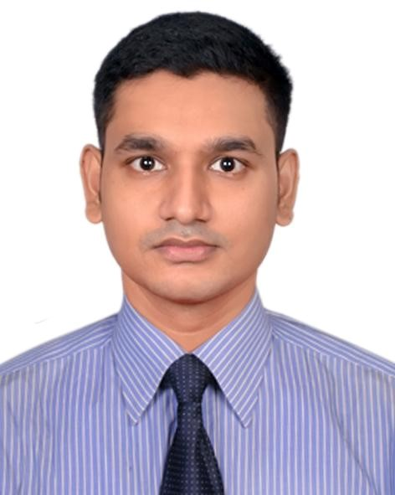

# CAREER OBJECTIVE

Desired to be a part of an immensely professional team prioritizing ethics, excellence, and innovation with a view to equipping myself with professional and life skills and making a significant contribution to the entire success of the company simultaneously.

|  |  |  |
| --- | --- | --- |
| **●** | **Her Power Project, ICT Division** | **Trainer**  Dec 03, 2023 – Nov 03, 2024  Women Call Center Agent, Lakshmipur  Sadar, Lakshmipur, Chattogram |
| **●** | **Genex Infosys Limited** | **Executive Trainer**  Nov 09, 2023 - till date |
| **●** | **Center for Career Development**  **(CCD) & Alumni Affairs** | **Former Intern**  (Event Management)  Dec 01, 2021- Mar 31, 2022  Green University of Bangladesh |

# ACADEMIC ACHIEVEMENT

**Bachelor of Arts/2022 Higher Secondary Certificate Secondary School Certificate**

**(BA Honours in English) (H.S.C)-Science/2013 (S.S.C)-Science/2011**

CGPA- 3.24 [on scale 4] GPA- 4.40 [on scale 5] GPA- 4.88 [on scale 5]

Green University of Mohadevpur Union Govt.University Oxford Academy, Shibaloy, Bangladesh, Dhaka College, Shibaloy, Manikganj Manikganj

**PROFESSIONAL PROFILE**

# TRAINING

|  |  |  |  |
| --- | --- | --- | --- |
| **Professional Customer Service** |  |  | **Accomplished**  Under SEIP & BACCO, 2023  Genex Infosys Limited |
| **ELT (Approaches & Methods**  **Language Teaching)** | **in** | **English** | **Accomplished**  Fall 2021, Department of English  Green University of Bangladesh |

|  |  |  |  |
| --- | --- | --- | --- |
| **Language** | **Computer Competence** | | **Professional Traits** |
| **Bangla:** Native Language | ●  ●  ● | Microsoft office  Applications  Google Suite  Canva, Chatgpt,  Magical, etc | **Personal:**   * Effective Communication * Presentation * Executive functioning * Enthusiasm * Adaptability |
| **English:** Advanced Level  Attended a professional  English Proficiency Test  ( Duolingo English Test  2023- 125*) |  |  | **Organizational:**   * Co-ordination * Observation & Decision making * People Management * Team work & Collaboration * Leadership |

# VOLUNTEERISM

|  |  |  |
| --- | --- | --- |
| **United Nations Youth and Students**  **Association of Bangladesh (UNYSAB)** | **Associate Member**  Batch: 15th  June 01, 2022 - July 31, 2023 |  |
|  | Address: House No. 519/A, Road  Dhanmondi, Dhaka 1209, Bangladesh | No.1, |

# EXTRACURRICULAR ACTIVITIES

|  |  |  |  |  |  |  |  |
| --- | --- | --- | --- | --- | --- | --- | --- |
| ● | Tour Organising | ● | Cooking | ● | Blood Donor | ● | Private Tutor ( 2017-2020) |

**SKILLS HIGHLIGHT**

# REFERENCES

**Mohammad Golam Mohiuddin**

Assistant Professor, Department of English

Green University of Bangladesh

Cell: +880 19 1580 3262

Email: mohiuddin@eng.green.edu.bd

# DECLARATION

**Mohammad Mostofa Jaman** Head of Partnership & PR

Genex Infosys Limited

Cell: +880 18 4710 0158

Email: mostofa.jaman@genexinfosys.com

I do hereby declare that the above information is correct to the best of my knowledge.

--------------------

Al Imran Emon